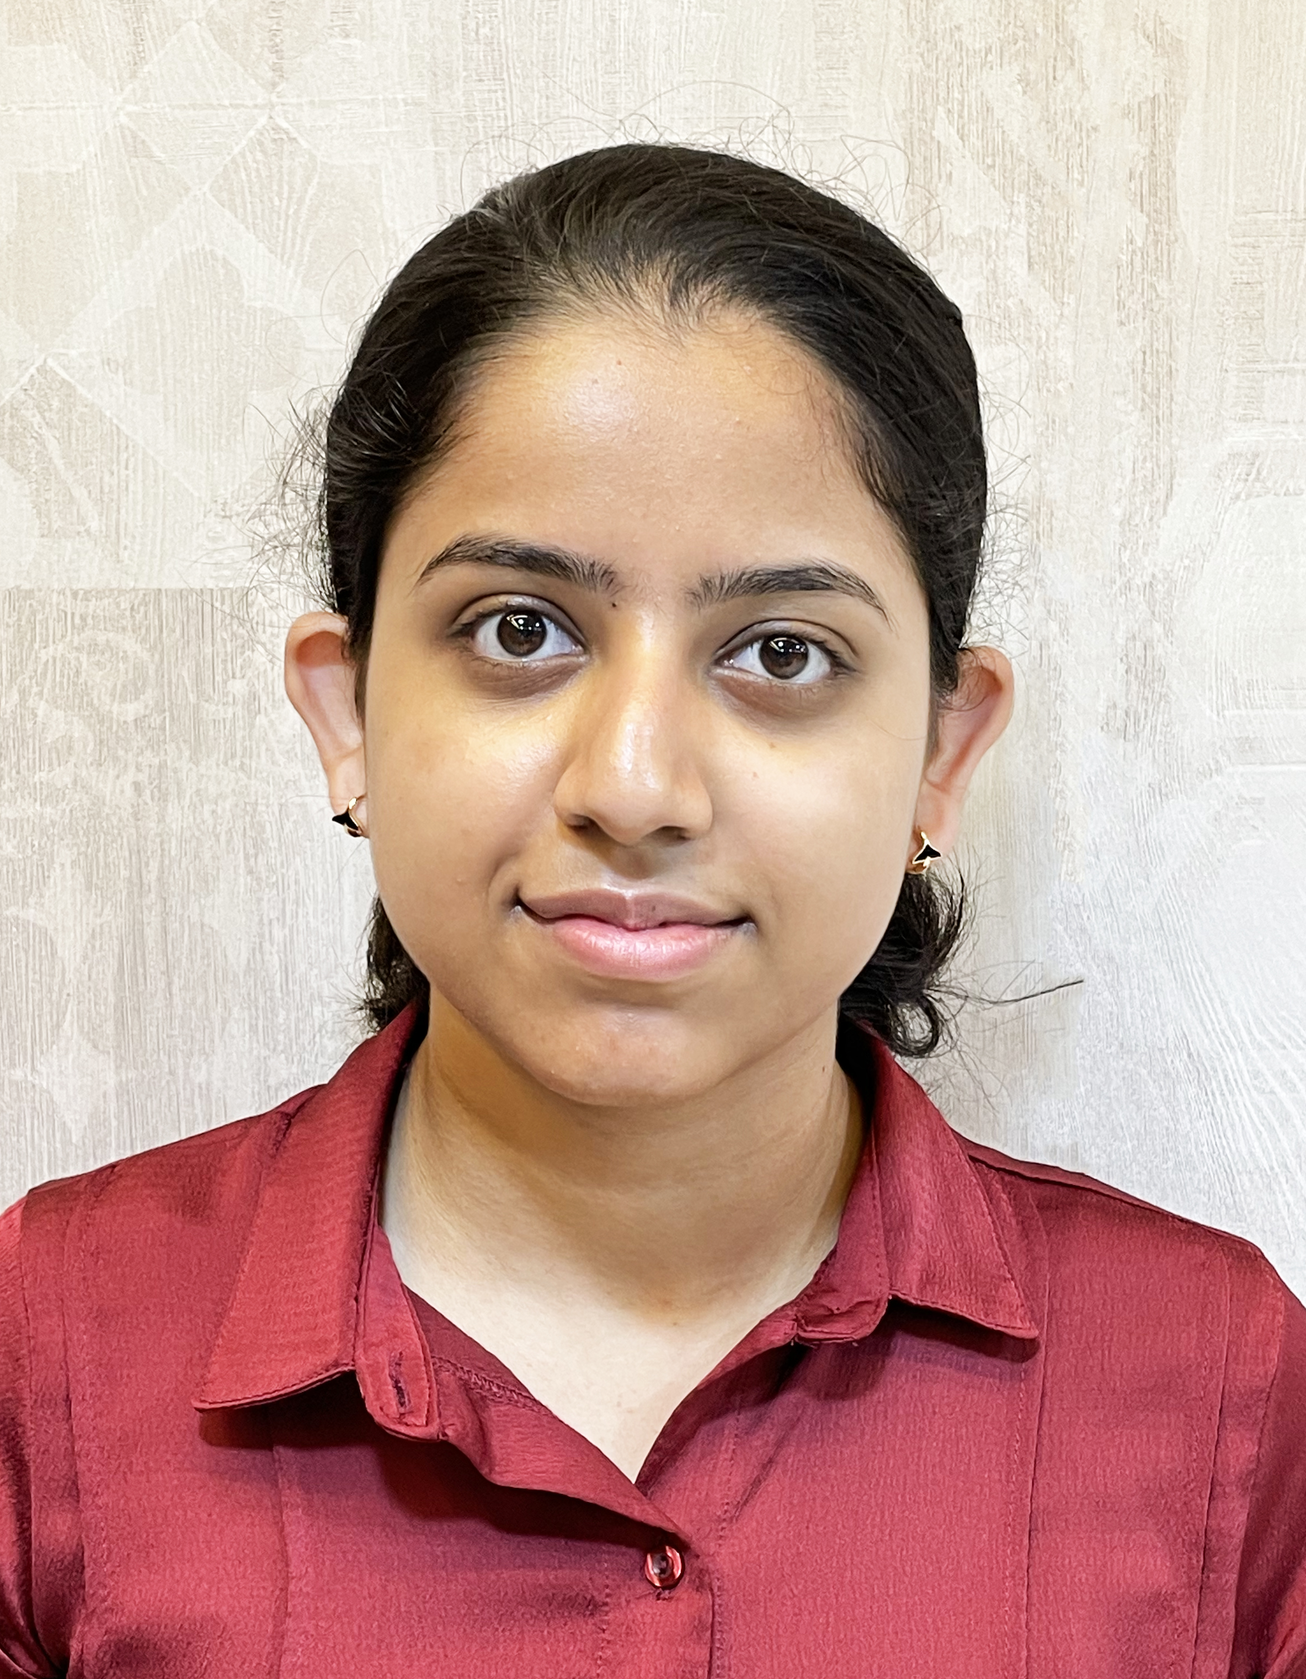

**Trishita Bandyopadhyay**

Ph: +918240192011

E-mail:

[trishita.bandyopadhyay15@gmail.com](mailto:biswadeepam@gmail.com)

______________________________________________________________

**Career Objective:** To work in a competitive and challenging environment and excel in my field each day, by acquiring new skills and mastering them.

**Academic Qualification:**

| | **Qualification** | **Name of School / College/ Institution** | **Board / University** | **Year of Passing** | **Marks (in %) / CGPA** | | --- | --- | --- | --- | --- | | M.A. French Language and Literature | English and Foreign Languages University, Hyderabad | EFLU, University | 2024 | N/A | | DELF A2 (Diplôme D’Études En Langue Française) | Alliance Française du Bengale | République Française Ministère De L’Éducation Nationale, De La Jeunesse Et Des Sports | 2021 | 89.50% | | DELF A1(Diplôme D’Études En Langue Française) | Alliance Française du Bengale | République Française Ministère De L’Éducation Nationale, De La Jeunesse Et Des Sports | 2019 | 90.50% | | Bachelor of Arts(final semester) | Chandernagore Government College | The University of Burdwan | 2022 | 8.93 | | 12th | St.Joseph’s Convent School,Chandannagar | ISC | 2019 | 89.75% | | 10th | St.Joseph’s Convent School,Chandannagar | ICSE | 2017 | 86% | |
| --- | --- | --- | --- | --- | --- | --- | --- | --- | --- | --- | --- | --- | --- | --- | --- | --- | --- | --- | --- | --- | --- | --- | --- | --- | --- | --- | --- | --- | --- | --- | --- | --- | --- | --- | --- |

**Interests / Hobbies:**

* Singing
* Dancing
* Reading
* Exploring New Languages
* Cooking
* Badminton
* Photography
* Drawing and Designing.

**Awards & Achievements:**

* Participated and Won in numerous cultural events and inter-school and inter-college singing competitions.
* Certified for achieving excellence in singing by a prestigious Gurukul.
* Currently training students in private with French courses.
* Helped several fellow college students with French lessons.
* Participated and won several sports competitions at school.

**Personal Details:**

Father’s Name : Sujit Kumar Bandyopadhyay

Date of Birth : August 9, 2001

Gender : Female

Languages Fluent in : English, Hindi, Bengali and French.

**Permanent Address :** Satghat, P.O., Gondolpara, Chandannagar, Hooghly- 712137

**Decleration**

I hereby declare that all the information given above is true and correct to the best of my knowledge. All the information shared in the resume is correct, and I take full responsibility for its correctness. I solemnly declare that the information in this resume is true to the best of my knowledge and belief.

(Trishita Bandyopadhyay)

Date : 22/5/2023